Department of Computer Science and Engineering
B.Tech III Semester
Academic Year 2026-2027
Data Analysis Essentials(2501AI06)
Corner Stone Project Documentation


ADITYA UNIVERSITY
Surampalem, Kakinada District
Andhra Pradesh - 533437


School of Computing

Department of Computer Science and Engineering

DATA ANALYSIS ESSENTIALS

CERTIFICATE
This is to certify that the Cornerstone project work entitled “UPI TRANSACTION ANALYSIS” is submitted by

K. SRI SAI SURYA MANIKANTA | (25B11CS002)
A. DIVIJA NAGA SAI TEJA SRI | (25B11CS005)
S. JASWANTHI | (25B11CS845)
T. MANOJ REDDY | (25B11CS946)

in partial fulfilment of the requirements for the award of the B.Tech. degree in Computer Science and Engineering for the academic year 2026–2027.

Project Guide | Head of the Department
K. Ashok Teja, M.Tech | Dr. A. Phani Sridhar, Ph.D.,
Assistant Professor, | Associate Professor & HOD
Department of CSE | Department of CSE

DECLARATION

We hereby declare that the project entitled “UPI TRANSACTION ANALYSIS” is our original work and is submitted to ADITYA UNIVERSITY, Surampalem, in partial fulfillment of the requirements for the award of the B.Tech. in Computer Science and Engineering.

We further declare that this project work has not been submitted, either in full or in part, for the award of any degree or diploma in this or any other institution. We also confirm that this work has been carried out with academic honesty and complies with the Institutional Academic Integrity and AI Usage Policy.

Place: Surampalem
Date:

By
K. SRI SAI SURYA MANIKANTA (25B11CS002)
A. DIVIJA NAGA SAI TEJA SRI (25B11CS005)
S. JASWANTHI (25B11CS845)
T. MANOJ REDDY (25B11CS946)

ACKNOWLEDGEMENT
It is with immense pleasure that we express our sincere gratitude to our Cornerstone Project Guide, Mr. K. Ashok Teja, Assistant Professor, who has guided us throughout the project. Her valuable support, encouragement, and guidance have greatly contributed to the successful completion of this work.

We would like to thank our Deputy Heads of the Department, Dr. K Chandra Shekar, Associate Professor, Dr. Hari Jyothula, Professor and Dr. P S Satya Prasad, Assistant Professor, Department of CSE, for their support and valuable suggestions.

Our deepest thanks to our Head of the Department, Dr. A Phani Sridhar, Associate Professor & HOD, for her inspiration and for providing all the necessary facilities and resources required for this project.

We also extend our sincere thanks to Dr. M.V. Rajesh, Associate Dean, School of Computing, for his encouragement and support during our project.

We would like to express our sincere gratitude to Dr. G. Suresh, Registrar;
Dr. A.Ramesh, Pro Vice-Chancellor (Engineering & Sciences); Dr. S. Rama Sree, Pro ViceChancellor (Academics); Dr. M.B. Srinivas, Vice-Chancellor; and Dr. M. Sreenivasa Reddy, Deputy Pro Chancellor and Management, Aditya University, for providing excellent infrastructure and state-of-the-art laboratories.

Finally, we would like to thank the faculty members, lab technicians, nonteaching staff, and our friends who have directly or indirectly supported us in completing this Cornerstone project successfully.

ABSTRACT

Unified Payments Interface (UPI) has become one of the most widely used digital payment systems in India, generating a large volume of transaction data every day. However, identifying customer spending behavior, transaction trends, and payment preferences from this data is difficult through manual analysis. This project analyzes the UPI Transactions 2024 dataset, sourced from a publicly available Kaggle repository, containing approximately 250,000 synthetic yet realistic UPI transaction records with attributes including transaction type, merchant category, transaction amount, transaction status, sender and receiver bank details, sender state, device type, network type, fraud indicators, and time-based information such as transaction hour, day of the week, and weekend indicators. Using Python, Pandas, and NumPy, the dataset is cleaned and preprocessed by handling missing values, removing duplicate records, validating data types, and processing timestamp information. Exploratory Data Analysis (EDA) using grouped aggregations, statistical summaries, and visualizations created with Matplotlib and Seaborn is performed to analyze customer spending across merchant categories, bank-wise transaction distribution, regional payment trends, transaction success rates, fraud occurrences, and time-based transaction patterns. The project aims to identify customer spending trends and transaction behavior, providing actionable insights that help merchants understand consumer preferences, optimize business strategies, and enable banks and payment service providers to improve transaction services and operational decision-making.

Table of contents
S. No. | Contents | Pages
1 | Title Page
2 | Certificate | i
3 | Declaration | ii
4 | Acknowledgement | iii
5 | Abstract | iv
6 | Table of Contents | v–vi
7 | List of Figures | vii
8 | List of Tables | viii
Chapter 1 | Introduction | 1
1.1 | Introduction to the Project | 1
1.2 | Problem Statement | 1
1.3 | Objectives of the Project | 1
1.4 | Scope of the Project | 1
Chapter 2 | Dataset Description and Understanding | 2–3
2.1 | Dataset Source | 2
2.2 | Dataset Description | 2
2.3 | Features / Attributes | 2
2.4 | Target Variable, if applicable | 3
2.5 | Dataset Statistics / Initial Exploration | 3
Chapter 3 | Data Preprocessing | 4–5
3.1 | Data Collection / Loading | 4
3.2 | Handling Missing Values | 4
3.3 | Handling Duplicate / Inconsistent Data | 4
3.4 | Feature and Attribute Selection | 4
3.5 | Standardization | 4
3.6 | Timestamp Handling | 4
3.7 | Transaction Amount and Fraud-Flag Validation | 5
3.8 | Other Project-Specific Preprocessing | 5
Chapter 4 | System Design and Methodology | 6–8
4.1 | Proposed Methodology | 6
4.2 | System Workflow / Architecture | 6
4.3 | Flowchart | 7
4.4 | Tools and Technologies Used | 7
4.5 | Algorithm / Method Used | 8
Chapter 5 | Implementation | 9–10
5.1 | Development Environment | 9
5.2 | Dataset Loading and Exploration | 9
5.3 | Preprocessing Implementation | 9
5.4 | Exploratory Data Analysis (EDA) | 9
5.5 | Model / Analysis Implementation | 9
5.6 | Important Code Explanation | 9
Chapter 6 | Data Visualization and Results | 11–19
6.1 | Transaction Type and Status Distributions | 11
6.2 | Fraud and Merchant Category Distributions | 12
6.3 | Transaction Amount Distribution | 14
6.4 | Average Transaction Amount Comparisons | 14
6.5 | Time-Based Activity | 15
6.6 | Fraud by Transaction Type and Merchant Category | 17
6.7 | Additional Fraud and Temporal Visualizations | 18
6.8 | Interpretation of Visualizations | 19
Chapter 7 | Data Quality Evaluation / Analysis of Results | 20–21
7.1 | Evaluation Metrics and Data Quality Measures | 20
7.2 | Consolidated Results | 20
7.3 | Result Interpretation | 20
7.4 | Discussion | 21
Chapter 8 | Output Screenshots | 22–25
8.1 | Input / Dataset Screenshots | 22
8.2 | Preprocessing Outputs | 23
8.3 | Visualization Outputs | 24
8.4 | Analysis Outputs | 25
Chapter 9 | Conclusion and Future Enhancements | 26
9.1 | Conclusion | 26
9.2 | Limitations | 26
9.3 | Future Enhancements | 26
 | References | 27
 | Appendix – Source Code | 28–31

List of Figures
S. No. | FIGURE NO. | NAME OF THE FIGURE | Page No.
1 | 4.2.1 | Overall Project Workflow | 6
2 | 4.3.1 | Project Flowchart | 7
3 | 6.1.1 | Transaction Type Distribution | 11
4 | 6.1.2 | Transaction Status Distribution | 11
5 | 6.2.1 | Fraud vs Non-Fraud | 12
6 | 6.2.2 | Transactions by Merchant Category | 12
7 | 6.2.3 | Transactions by Device Type | 13
8 | 6.2.4 | Transactions by Network Type | 13
9 | 6.3.1 | Distribution of Transaction Amounts | 14
10 | 6.4.1 | Average Transaction Amount by Type | 14
11 | 6.4.2 | Average Amount: Fraud vs Non-Fraud | 15
12 | 6.5.1 | Transaction Activity by Hour | 15
13 | 6.5.2 | Transactions by Day of Week | 16
14 | 6.5.3 | Weekday vs Weekend | 16
15 | 6.6.1 | Fraudulent Transactions by Type | 17
16 | 6.6.2 | Fraudulent Transactions by Merchant | 17
17 | 6.7.1 | Fraudulent Transactions by Hour | 18
18 | 6.7.2 | Fraudulent Transactions by Device | 18
19 | 6.7.3 | Fraudulent Transactions by Network | 19
20 | 6.7.4 | Top Sender States by Fraud Flag | 19
21 | 8.1.1 | Dataset Loading and Initial Inspection | 22
22 | 8.2.1 | Data Validation and Cleaning Output | 23
23 | 8.3.1 | Aggregation Output | 24
24 | 8.4.1 | Results and Interpretation Output | 25

LIST OF TABLES
S. No. | TABLE NO. | NAME OF THE TABLE | Page No.
1 | 2.2.1 | Dataset Profile and Dimensions | 2
2 | 2.3.1 | Core Dataset Attributes | 3
3 | 4.4.1 | Tools and Technologies Used | 7
4 | 7.1.1 | Data Quality Measures | 20
5 | 7.2.1 | Consolidated Project Results | 20

CHAPTER 1
INTRODUCTION

1.1 Introduction to the Project
Unified Payments Interface (UPI) produces large volumes of transaction records. Each record can contain transaction type, amount, status, merchant category, sender and receiver attributes, banks, device, network, time, sender state, and a fraud indicator. This project applies a systematic data-analysis workflow to turn those records into validated summaries, comparisons, visualizations, and findings.
The project uses the supplied UPI Transactions 2024 dataset and follows eight stages: data loading and reading, data acquisition and filtering, data extraction, data validation and cleaning, data aggregation and representation, data analysis, data visualization, and results interpretation. Python, Pandas, NumPy, and Matplotlib are used across the workflow.

1.2 Problem Statement
Analysing individual UPI transaction records manually makes it difficult to identify overall behaviour and recurring patterns. The project addresses the need to inspect data quality, retain the relevant transaction attributes, aggregate records by meaningful categories, calculate descriptive measures, visualize transaction activity, and examine how the dataset’s existing fraud flag is distributed across transaction characteristics.

1.3 Objectives of the Project
• Load and inspect the UPI transaction dataset.
• Identify missing values, duplicate rows, data types, and inconsistent field representations.
• Filter and retain the 17 core transaction attributes from the 27-column noisy input.
• Extract and validate timestamp-related information.
• Aggregate transaction counts, totals, and averages by transaction type and merchant category.
• Analyse transaction status, transaction amount, time, device, network, sender state, and existing fraud flags.
• Create visualizations using Matplotlib and interpret the resulting patterns.
• Document findings and limitations without claiming causal relationships or an unimplemented prediction model.

1.4 Scope of the Project
The scope is descriptive and exploratory. It covers transaction volume and value, transaction status and type, merchant category, transaction timing, weekday/weekend activity, device type, network type, sender state, and the distribution of records marked by the dataset’s fraud_flag. It does not include training a fraud-classification model or deploying a production fraud-detection system.

CHAPTER 2
DATASET DESCRIPTION AND UNDERSTANDING

2.1 Dataset Source
The supplied repository identifies the source as the UPI Transactions 2024 Dataset. The project contains an uncleaned/noisy CSV, a cleaned CSV, stage-wise Jupyter notebooks, README files, and saved output PDFs. The data is transaction-level and is used for descriptive analysis.

2.2 Dataset Description
The noisy working input contains 250,000 rows and 27 columns. Ten additional device, application, session, and context fields are removed to retain the 17 core transaction attributes needed for the analysis. The final cleaned dataset contains 250,000 rows and 17 columns. All transaction rows are preserved during this reduction.
Table 2.2.1: Dataset Profile and Final Dimensions
Property | Value
Records in noisy input | 250,000
Columns in noisy input | 27
Core attributes retained | 17
Noise/context columns removed | 10
Missing cells in noisy input | 124,747
Duplicate rows | 0
Rows after cleaning | 250,000
Columns after cleaning | 17
Missing values after cleaning | 0

2.3 Features / Attributes
Table 2.3.1: Description of Core Dataset Attributes
Attribute | Description
Transaction ID | Transaction identifier
time_stamp | Date and time of transaction
Transaction_Type | UPI transaction type: P2P, P2M, Bill Payment, Recharge
merchant category | Merchant category associated with the transaction
amount_INR | Transaction amount in Indian rupees
Transaction Status | Transaction outcome status
sender_agegroup | Sender age-group attribute
receiver_age_group | Receiver age-group attribute
Sender State | State associated with the sender
sender bank | Sender bank
Receiver_Bank | Receiver bank
device type | Device category used for transaction
Network Type | Network category used for transaction
Fraud Flag | Existing fraud indicator in the dataset
hour of day | Hour of transaction
Day Of Week | Day of week associated with transaction
is weekend | Indicator for weekend transactions

2.4 Target Variable, if applicable
A prediction target is not applicable to the implemented project. The fraud_flag field already exists in the dataset and is analysed as a label; it is not used to train a fraud-prediction model. The project therefore reports counts and distributions of the supplied flag rather than predicted fraud probabilities.

2.5 Dataset Statistics / Initial Exploration
The initial loading stage checks dataset shape, column names, data types, sample records, missing values, and duplicate rows. The noisy input contains 124,747 missing cells before cleaning and no duplicate rows. Following validation and cleaning, the 250,000 × 17 analytical dataset has no missing values and no duplicate rows.

CHAPTER 3
DATA PREPROCESSING

3.1 Data Collection / Loading
The notebooks load the supplied CSV files with Pandas. The initial stage inspects the shape, columns, data types, first records, missing-value counts, and duplicate records before any filtering or aggregation.

Example: loading and initial inspection
import pandas as pd
df = pd.read_csv("/content/Dataset(1).csv")
print(df.shape)
print(df.columns)
print(df.dtypes)
print(df.isnull().sum())
print(df.duplicated().sum())

3.2 Handling Missing Values
The noisy input contains 124,747 missing cells across its 27 columns. The validation and cleaning stage standardizes missing representations, resolves missing values in the retained analytical fields, and validates the final dataset. The final cleaned dataset contains zero missing values. The reported initial missing-cell total refers to the noisy input before cleaning, not to the final 17-column dataset.

3.3 Handling Duplicate / Inconsistent Data
The project checks for duplicate rows and validates transaction type, transaction status, transaction amount, timestamp, and fraud flag. The source reports zero duplicate rows. Inconsistent status variants and mixed representations of the fraud flag are standardized before final validation.

3.4 Feature and Attribute Selection
The cleaning stage removes ten noise/context columns that are not required for the core analysis: battery level %, App Version, device storage free gb, screen brightness %, Device Language, GPS accuracy m, nearby wifi count, session duration sec, notifications last hour, and merchant distance km. The 17 core transaction attributes are retained.

3.5 Standardization
Column names and categorical values are standardized to provide consistent grouping and comparison. Transaction status values are normalized to SUCCESS and FAILED, transaction types are validated, and fraud_flag values are normalized to the expected binary representation.

3.6 Timestamp Handling
The timestamp field is converted to a consistent datetime representation. Temporal attributes used in the project include hour of day, day of week, and weekend indicator. The extraction stage also derives date, month, year, week number, day of month, and day name for time-based analysis where required.

3.7 Transaction Amount and Fraud-Flag Validation
Transaction amounts are checked for negative or invalid values, and the final cleaned dataset reports zero negative transaction amounts. Fraud flags are checked for invalid entries and standardized; the final validation reports zero invalid fraud-flag values.

3.8 Other Project-Specific Preprocessing
• Retain all 250,000 transaction rows while reducing the working schema from 27 to 17 columns.
• Remove ten additional device, application, session, and contextual fields.
• Standardize timestamp, transaction status, transaction type, amount, and fraud flag representations.
• Confirm the final dataset has 0 missing values, 0 duplicate rows, and 0 negative transaction amounts.

CHAPTER 4
SYSTEM DESIGN AND METHODOLOGY

4.1 Proposed Methodology
The implemented method is a staged descriptive data-analysis workflow. It moves from raw data inspection through attribute selection, timestamp extraction, validation, aggregation, statistical analysis, visualization, and interpretation. Each stage has a dedicated notebook and supporting README/output in the supplied repository.

4.2 System Workflow / Architecture
The overall workflow represented by the project files is shown below. It covers the eight stages documented in the repository.
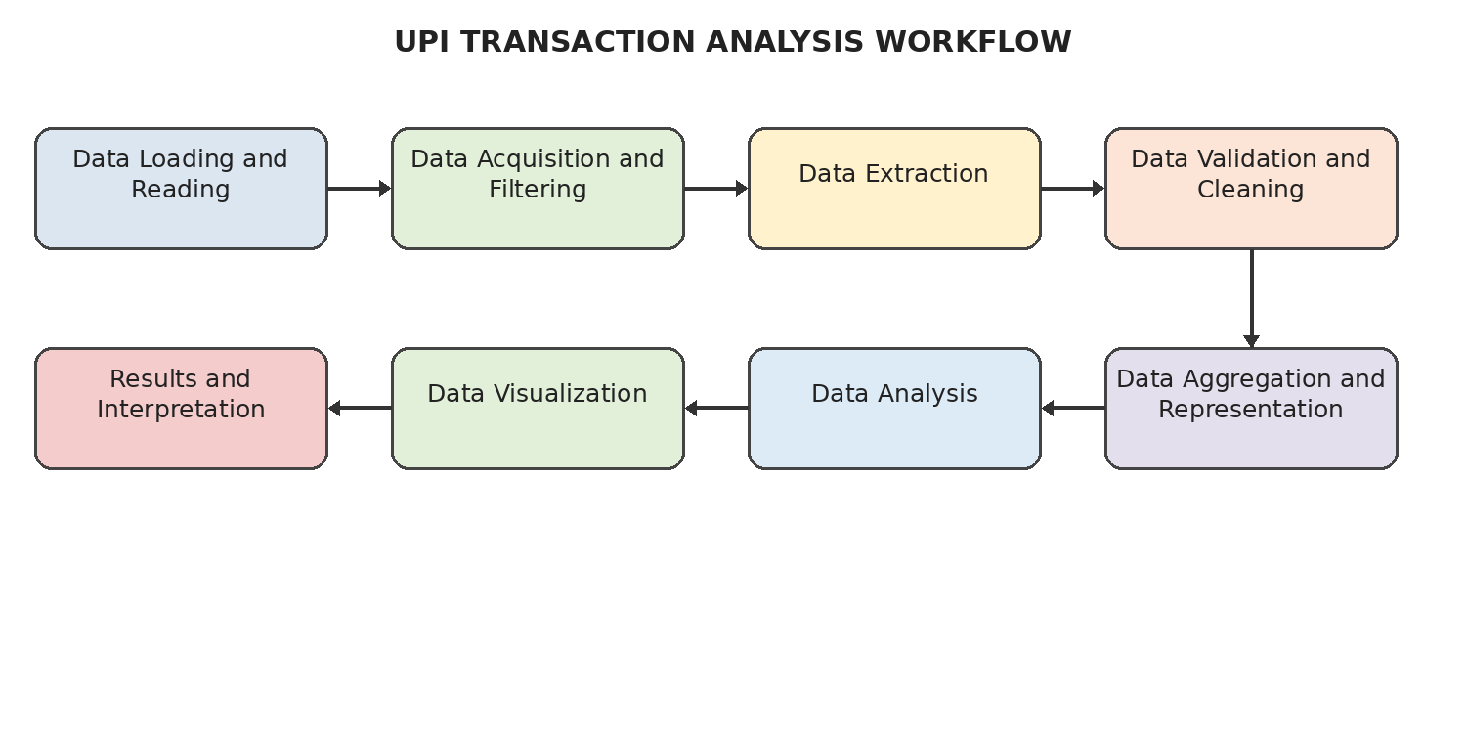
Figure 4.2.1: Overall Project Workflow
The workflow is analytical rather than predictive. The fraud flag is a pre-existing field and is grouped and compared as part of descriptive analysis.

4.3 Flowchart
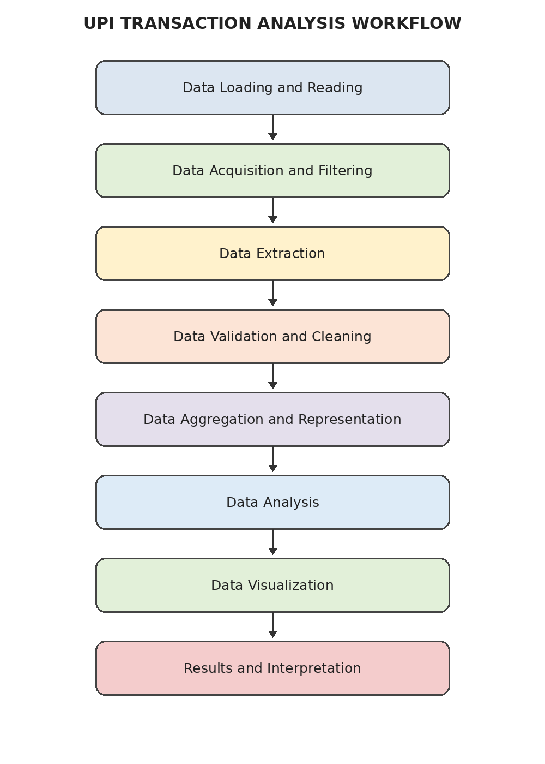
Figure 4.3.1: Project Flowchart

4.4 Tools and Technologies Used
Table 4.4.1: Tools and Technologies Used
Tool / Technology | Purpose
Python | Programming language for data analysis
Jupyter Notebook | Stage-wise development and experimentation
Pandas | CSV loading, filtering, grouping, aggregation, and cleaning
NumPy | Numerical operations and calculations
Matplotlib | Transaction and fraud-pattern visualizations
Google Colab / VS Code | Notebook execution environments documented in the project materials
CSV | Storage format for noisy and cleaned transaction data
Git / GitHub repository | Project source and staged deliverables

4.5 Algorithm / Method Used
The project uses descriptive statistics and group-based aggregation rather than a machine-learning algorithm. Pandas value_counts, groupby, aggregation, sorting, and filtering are used to calculate transaction counts, total amounts, average amounts, and fraud-flag counts across transaction type, merchant category, hour, device, network, and sender state. Matplotlib is used to present the summaries visually.

CHAPTER 5
IMPLEMENTATION

5.1 Development Environment
The repository is organized into eight stage folders. Each stage contains a Jupyter Notebook, README, and saved Output.pdf where supplied. Python, Pandas, NumPy, and Matplotlib are the principal technologies used in the implemented analysis.

5.2 Dataset Loading and Exploration
The first notebook reads the transaction CSV and displays its shape, column names, data types, sample records, missing-value counts, and duplicate-row count. The noisy input is recorded as 250,000 rows and 27 columns.

5.3 Preprocessing Implementation
The validation and cleaning notebook retains the 17 core attributes, removes ten noise/context columns, standardizes the relevant fields, validates transaction amount and fraud flag, and prepares the final cleaned dataset. The output retains 250,000 rows and reports no missing values, duplicate rows, negative amounts, or invalid fraud flags.

5.4 Exploratory Data Analysis (EDA)
The analysis examines overall transaction totals and averages, status and type distributions, merchant-category counts, hourly transaction volume, device and network usage, transaction amount distribution, weekday/weekend activity, and the distribution of existing fraud flags across relevant categories.

5.5 Model / Analysis Implementation
No predictive model is implemented. The analysis uses grouped descriptive summaries. The most common transaction type is P2P, with 112,445 records (44.98%). The highest overall hourly volume is at 19:00, with 21,232 transactions. Fraud-flagged records total 480 (0.19% of the dataset), and P2P has the largest fraud-flag count at 206.

5.6 Important Code Explanation

Counting transaction types
df["transaction type"].value_counts()
The value_counts operation calculates the number of records in each transaction type. Similar groupby and aggregation operations are used for merchant categories, time periods, devices, networks, sender states, and fraud-flagged records.

Hourly transaction counts
hour_counts = df["hour_of_day"].value_counts().sort_index()
Sorting by hour preserves the 24-hour order so that hourly transaction activity can be compared consistently and plotted as a time-of-day pattern.

Fraud counts by transaction type
fraud_by_type = (
df.groupby("transaction type")["fraud_flag"]
.sum()
.sort_values(ascending=False)
)
Summing the standardized binary fraud flag within each group produces the observed number of fraud-flagged transactions in each transaction type. This is a descriptive count, not a prediction or a causal explanation.

CHAPTER 6
DATA VISUALIZATION AND RESULTS
The supplied project includes eighteen Matplotlib visualizations. The charts below correspond to the transaction and fraud analyses in the project materials and are presented in the same numbered-caption style as the reference document.

6.1 Transaction Type and Status Distributions
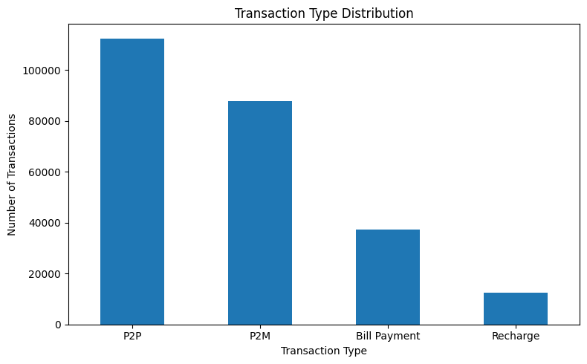
Figure 6.1.1: Transaction Type Distribution
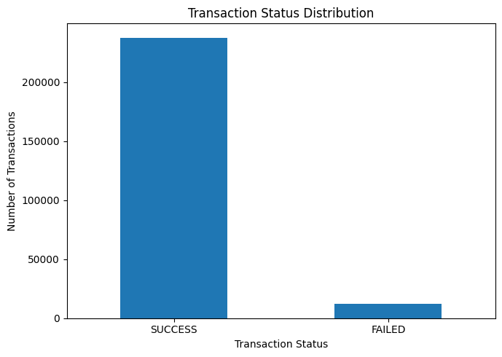
Figure 6.1.2: Transaction Status Distribution

6.2 Fraud and Merchant Category Distributions
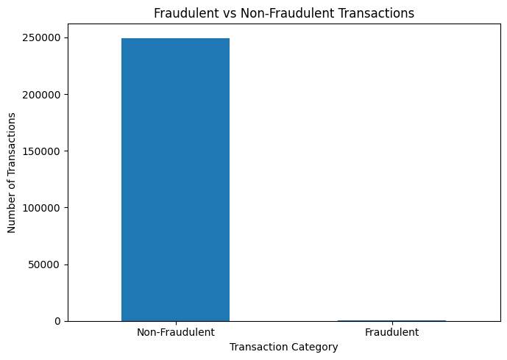
Figure 6.2.1: Fraud vs Non-Fraud
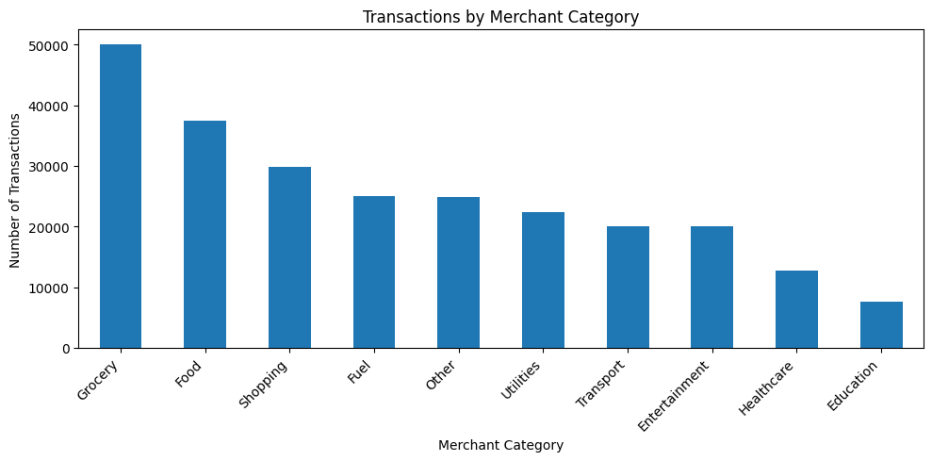
Figure 6.2.2: Transactions by Merchant Category
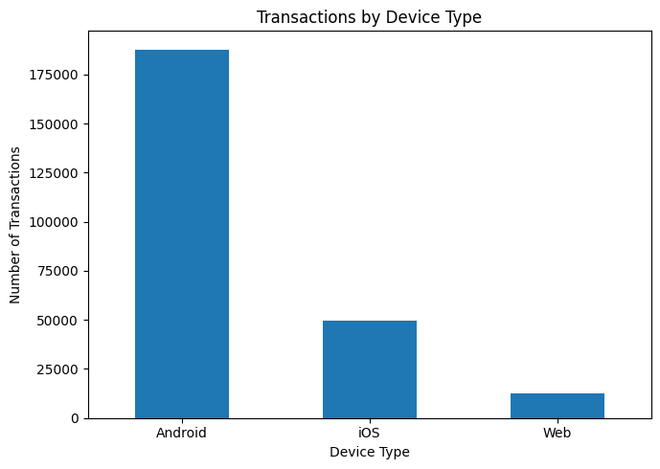
Figure 6.2.3: Transactions by Device Type
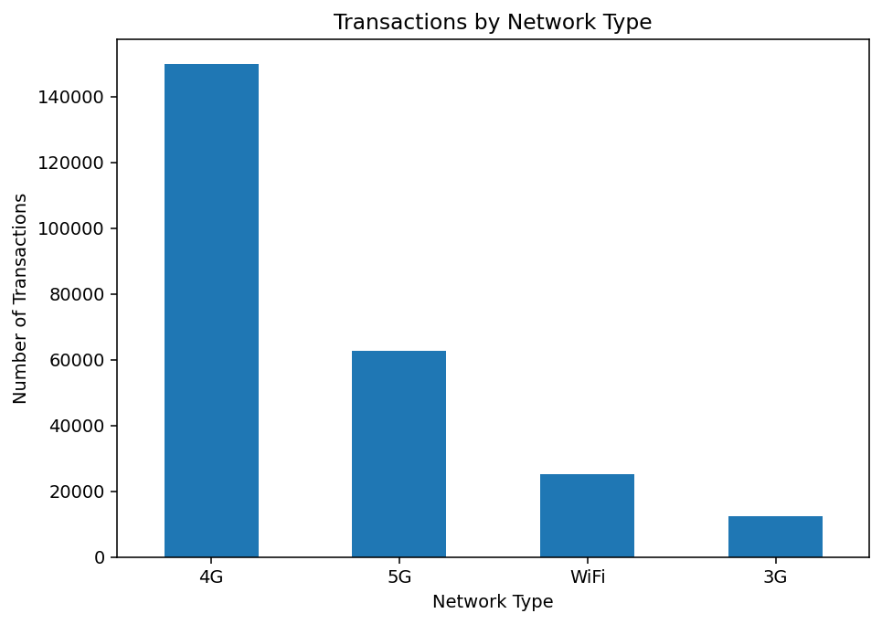
Figure 6.2.4: Transactions by Network Type

6.3 Transaction Amount Distribution
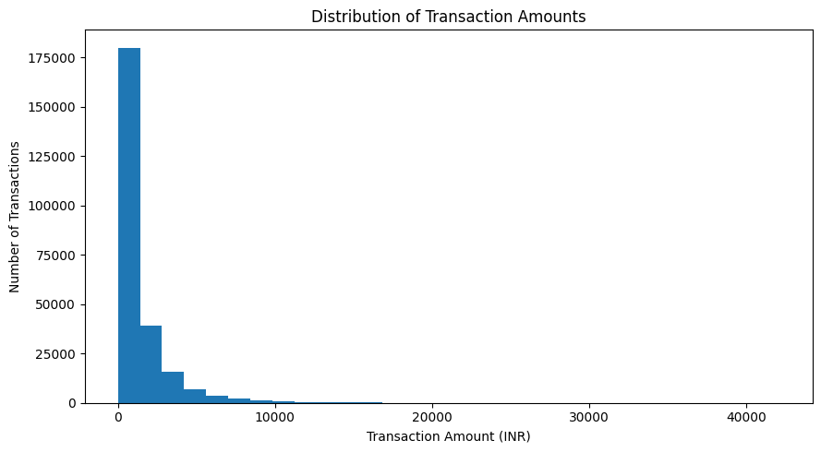
Figure 6.3.1: Distribution of Transaction Amounts

6.4 Average Transaction Amount Comparisons
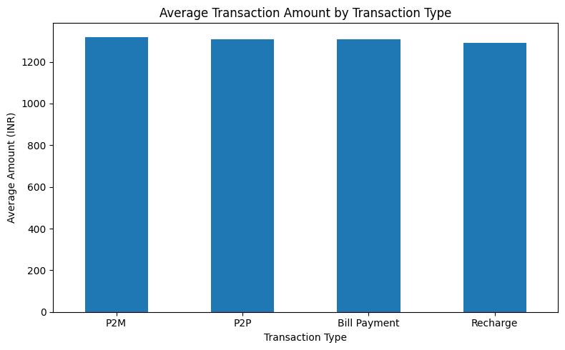
Figure 6.4.1: Average Transaction Amount by Transaction Type
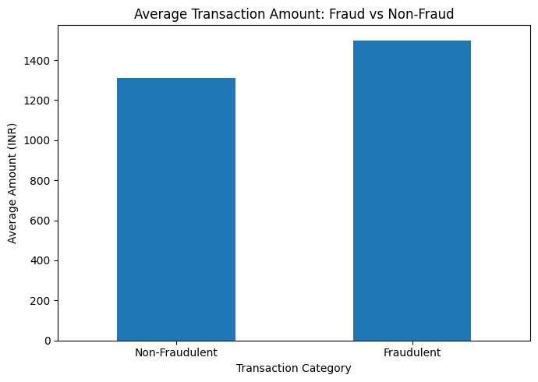
Figure 6.4.2: Average Transaction Amount: Fraud vs Non-Fraud

6.5 Time-Based Activity
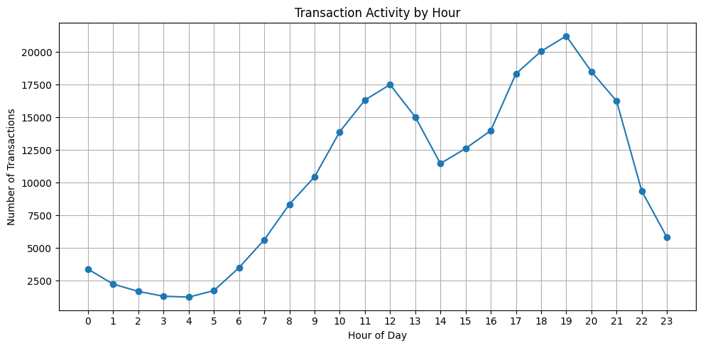
Figure 6.5.1: Transaction Activity by Hour
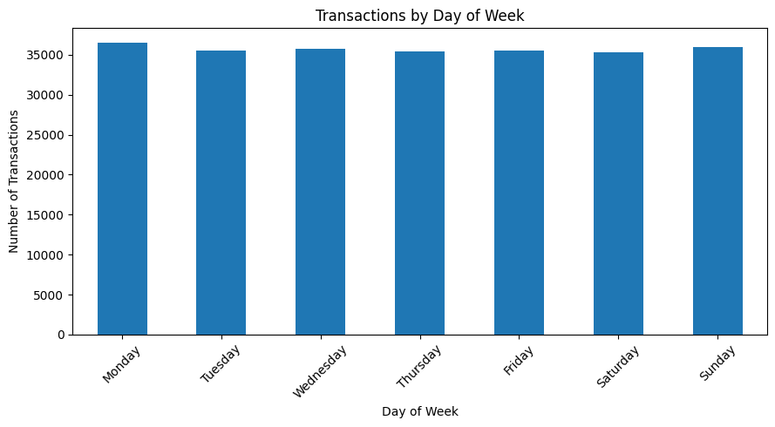
Figure 6.5.2: Transactions by Day of Week
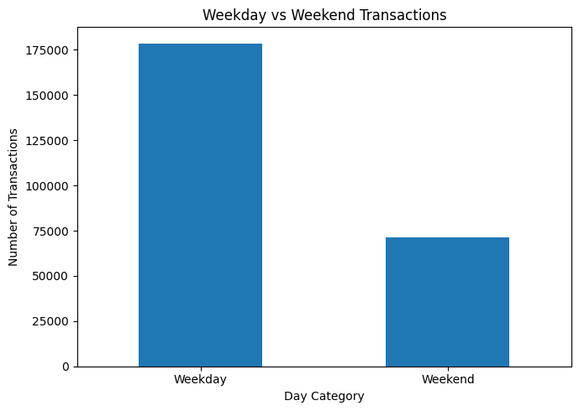
Figure 6.5.3: Weekday vs Weekend

6.6 Fraud by Transaction Type and Merchant Category
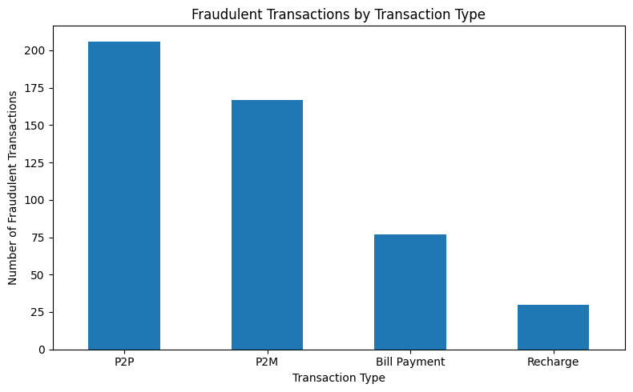
Figure 6.6.1: Fraudulent Transactions by Transaction Type
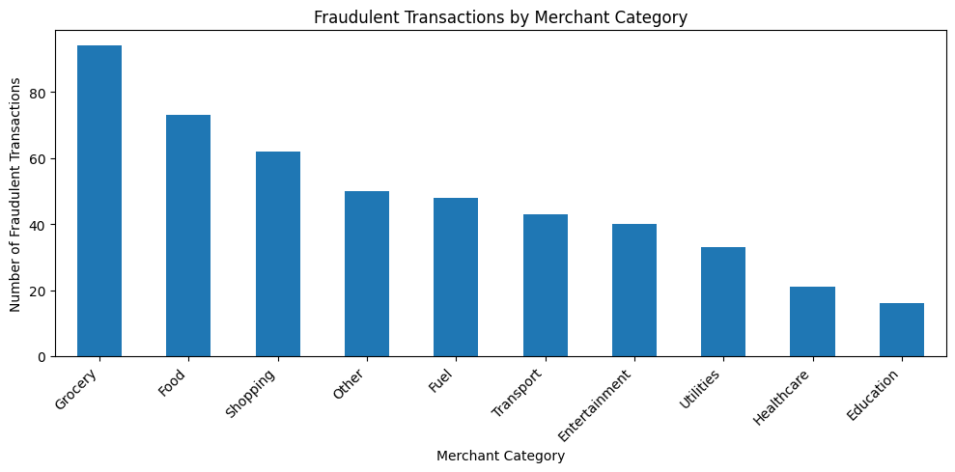
Figure 6.6.2: Fraudulent Transactions by Merchant Category

6.7 Additional Fraud and Temporal Visualizations
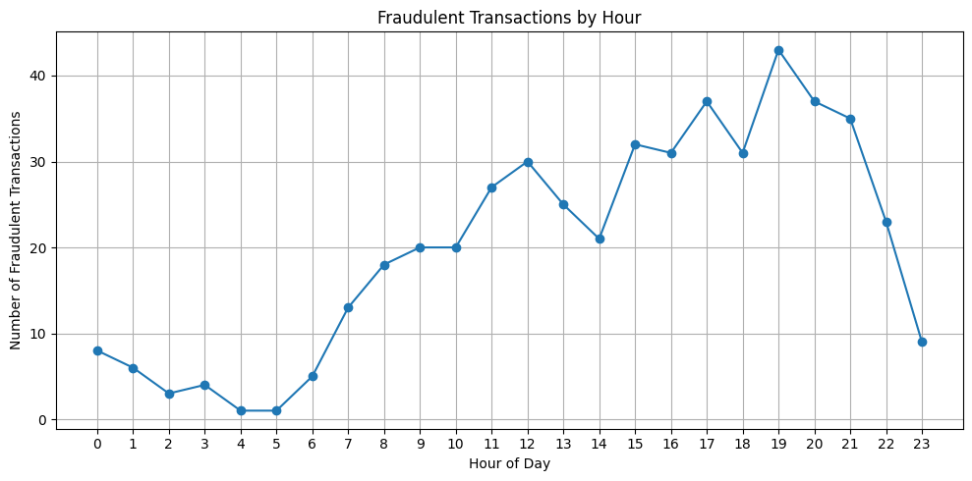
Figure 6.7.1: Fraudulent Transactions by Hour
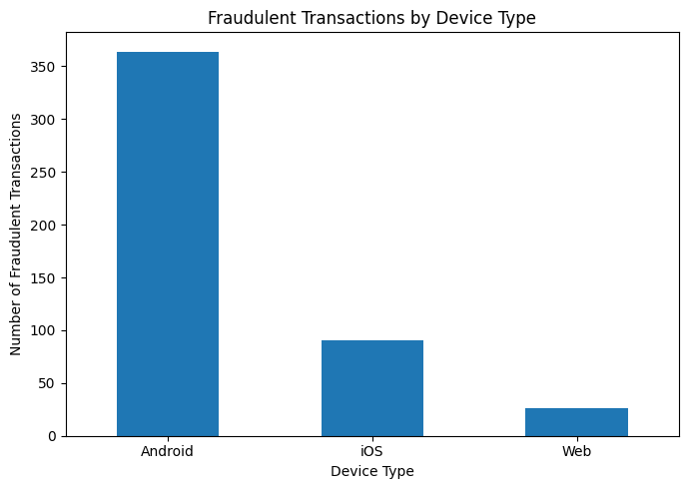
Figure 6.7.2: Fraudulent Transactions by Device Type
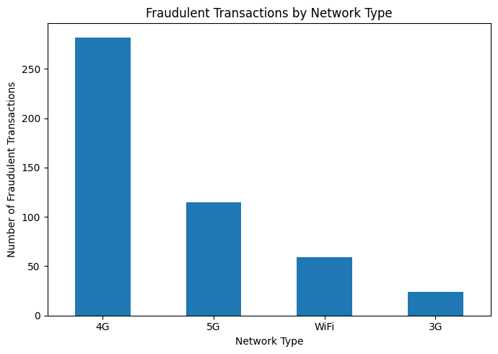
Figure 6.7.3: Fraudulent Transactions by Network Type
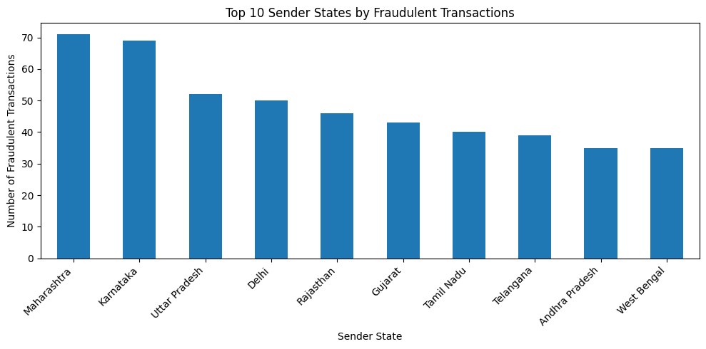
Figure 6.7.4: Top Sender States by Fraud-Flagged Transactions

6.8 Interpretation of Visualizations
The transaction-type chart shows P2P as the largest type by count, followed by P2M, Bill Payment, and Recharge. The status chart shows a high proportion of SUCCESS records. Hourly activity is not uniform: 19:00 is the busiest hour in the supplied analysis. The amount distribution is strongly right-skewed, while the fraud charts show that the existing fraud-flagged records are a small minority of the dataset. Differences in counts across device, network, merchant, or state categories are descriptive and do not establish that those attributes cause fraud.

CHAPTER 7
DATA QUALITY EVALUATION / ANALYSIS OF RESULTS

7.1 Evaluation Metrics and Data Quality Measures
Table 7.1.1: Data Quality and Descriptive Measures
Measure | Result | Purpose
Rows in cleaned dataset | 250,000 | Confirms transaction rows preserved
Core columns retained | 17 | Defines analytical schema
Missing cells in noisy input | 124,747 | Documents initial data-quality burden
Missing values after cleaning | 0 | Confirms final retained fields are complete
Duplicate rows | 0 | Duplicate check result
Negative transaction amounts | 0 | Amount validation result
Invalid fraud flags | 0 | Fraud indicator validation result

7.2 Consolidated Results
Table 7.2.1: Consolidated Project Results
Metric / Category | Count or Value | Percentage / Note
Total transactions | 250,000 | 100%
Total transaction value | ₹327,939,009 | Approximately ₹327.94 million
Average transaction amount | ₹1,311.76 | Per transaction
Minimum transaction amount | ₹10 | Observed minimum
Maximum transaction amount | ₹42,099 | Observed maximum
SUCCESS | 237,624 | 95.05%
FAILED | 12,376 | 4.95%
P2P | 112,445 | 44.98%
P2M | 87,660 | 35.06%
Bill Payment | 37,368 | 14.95%
Recharge | 12,527 | 5.01%
Fraud-flagged | 480 | 0.19%
Non-fraudulent | 249,520 | 99.81%
Busiest hour | 19:00 | 21,232 transactions
Highest hourly fraud count | 19:00 | 43 fraud-flagged records
P2P fraud-flagged records | 206 | Highest count by transaction type
Android fraud-flagged records | 364 | Highest device count
4G fraud-flagged records | 282 | Highest network count
Maharashtra fraud-flagged records | 71 | Sender-state count

7.3 Result Interpretation
P2P is the most common transaction type and accounts for 44.98% of records. Successful transactions account for 95.05%, while 4.95% are marked FAILED. The total transaction value is ₹327,939,009, with a mean transaction amount of ₹1,311.76. Fraud-flagged records total 480, or approximately 0.19% of the dataset. Their average transaction amount is ₹1,499.23, compared with ₹1,311.40 for the non-fraudulent group. This difference is an observed descriptive comparison and does not establish why the groups differ.

7.4 Discussion
The stage-wise workflow provides a repeatable path from raw CSV files to validated analytical summaries and visual outputs. The cleaned dataset preserves all 250,000 rows while reducing the schema to the 17 attributes required for analysis. The findings are useful for describing the supplied dataset, but should not be treated as universal UPI transaction rates or as a production fraud-risk assessment.

CHAPTER 8
OUTPUT SCREENSHOTS

8.1 Input / Dataset Screenshots
The following screenshot is taken from the supplied Stage 1 Data Loading and Reading output PDF. It is included as an implementation artifact rather than recreated as a mock screenshot.
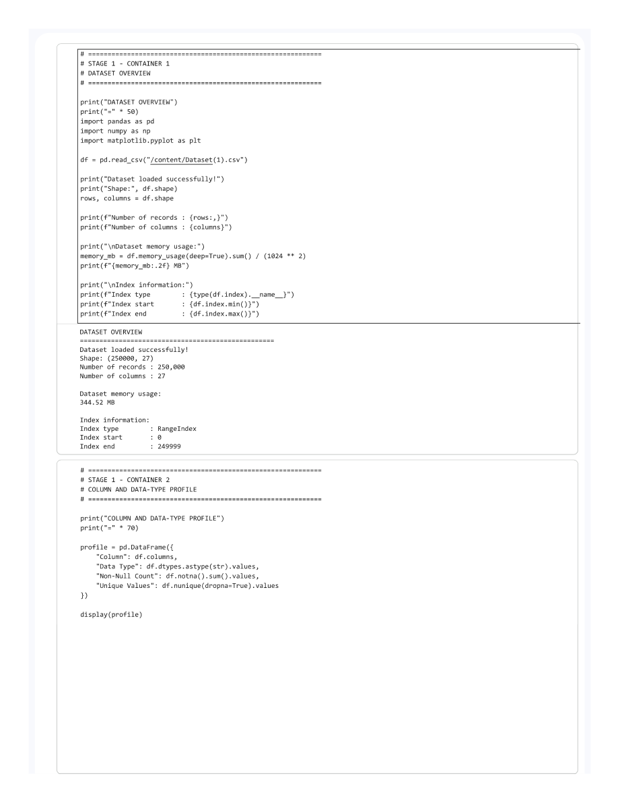
Figure 8.1.1: Dataset Loading and Initial Inspection Output

8.2 Preprocessing Outputs
The screenshot below is taken from the supplied Stage 4 Data Validation and Cleaning output PDF and records the actual notebook execution output for the cleaning stage.
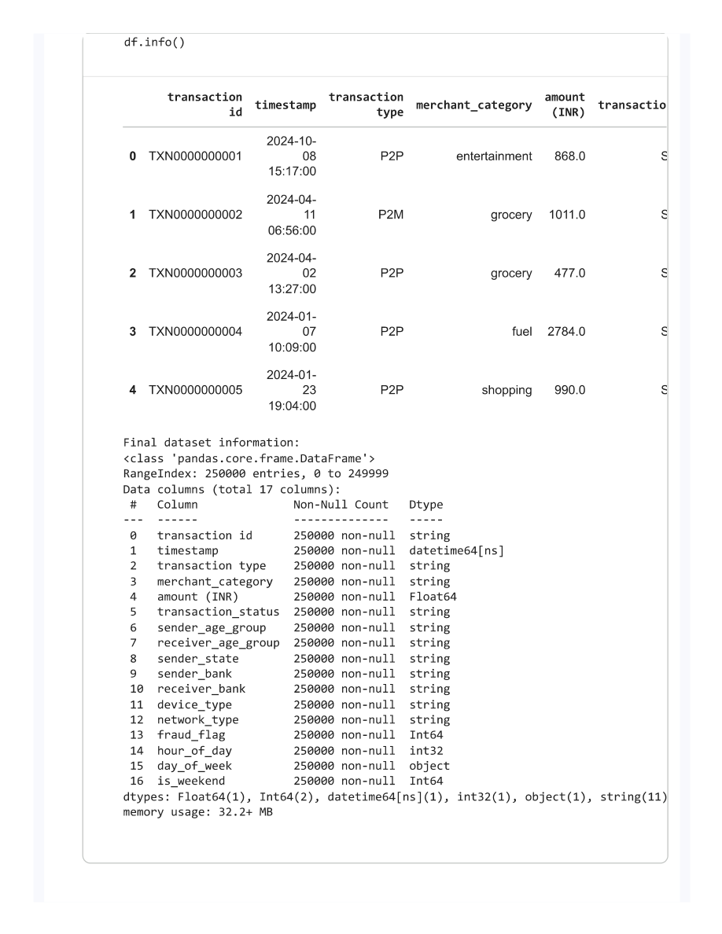
Figure 8.2.1: Data Validation and Cleaning Output

8.3 Visualization Outputs
The screenshot below is taken from the supplied Stage 5 Data Aggregation and Representation output PDF and shows an actual stage output from the project repository.
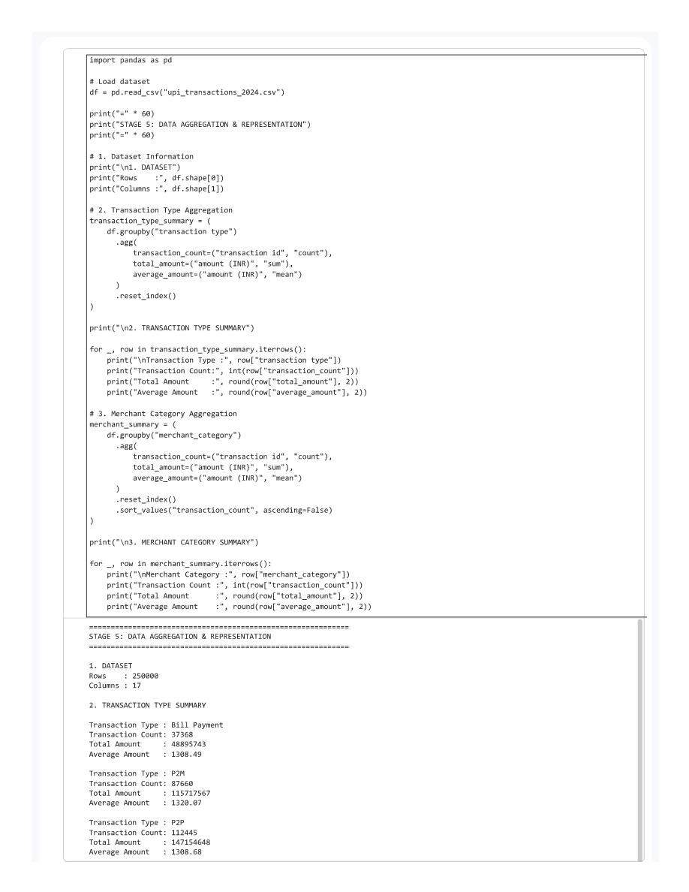
Figure 8.3.1: Data Aggregation and Representation Output

8.4 Analysis Outputs
The screenshot below is taken from the supplied Stage 8 Results and Interpretation output PDF. It is provided as evidence of the results-stage notebook output.
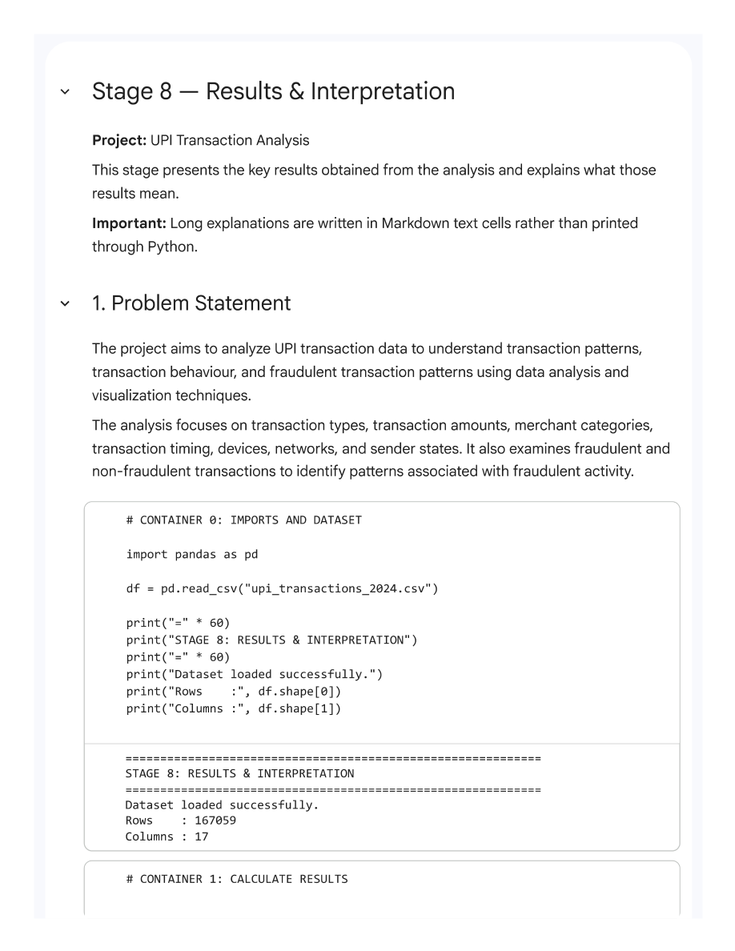
Figure 8.4.1: Results and Interpretation Output

CHAPTER 9
CONCLUSION AND FUTURE ENHANCEMENTS

9.1 Conclusion
The UPI Transaction Analysis project applies an eight-stage Python data-analysis workflow to 250,000 transaction records. The noisy 27-column input is reduced to 17 core transaction attributes, and the final cleaned dataset contains no missing values or duplicate rows. The analysis summarizes transaction volume and value, transaction status and type, merchant categories, time-based activity, device and network use, sender state, and the distribution of existing fraud-flagged records. Eighteen visualizations support interpretation of the results.

9.2 Limitations
• The analysis uses a fixed supplied dataset rather than a live UPI transaction stream.
• The fraud_flag already exists in the dataset; the project does not train or evaluate a fraud-prediction model.
• The reported patterns are descriptive and do not establish causation.
• Raw fraud counts should be interpreted alongside category sizes before comparing relative risk.
• Results describe the supplied dataset and may not generalize to other periods or transaction populations.

9.3 Future Enhancements
• Develop an interactive dashboard for filtering transaction and fraud summaries.
• Repeat the analysis on larger or periodically updated datasets.
• Add suitable statistical tests to assess whether observed group differences are meaningful.
• If a fraud-prediction model is pursued, define a separate supervised-learning workflow and evaluate it with appropriate metrics and validation.
• Explore longer-term temporal patterns and automated reporting.

REFERENCES
1. Kaggle provided CSV Dataset: UPI_Transactions_2024.csv
2. Project implementation notebook:UPI_Transaction_Analysis_Project.ipynb
3. Pandas Documentation – Python Data Analysis Library.
4. NumPy Documentation – Numerical Computing with Python.
5. Matplotlib Documentation – Python Data Visualization.
6. Python Documentation – Python Programming Language.

APPENDIX – SOURCE CODE
The following selected source excerpts are taken from the supplied stage notebooks. They illustrate the implemented workflow; the full notebooks and stage outputs remain in the project ZIP.

APPENDIX 1: DATA LOADING AND READING

Code excerpt
# ============================================================
# STAGE 1 - CONTAINER 1
# DATASET OVERVIEW
# ============================================================
print("DATASET OVERVIEW")
print("=" * 50)
import pandas as pd
import numpy as np
import matplotlib.pyplot as plt
df = pd.read_csv("/content/Dataset(1).csv")
print("Dataset loaded successfully!")
print("Shape:", df.shape)
rows, columns = df.shape
print(f"Number of records : {rows:,}")
print(f"Number of columns : {columns}")
print("\nDataset memory usage:")
memory_mb = df.memory_usage(deep=True).sum() / (1024 ** 2)
print(f"{memory_mb:.2f} MB")
print("\nIndex information:")
print(f"Index type : {type(df.index).__name__}")
print(f"Index start : {df.index.min()}")
print(f"Index end : {df.index.max()}")

APPENDIX 2: DATA ACQUISITION AND FILTERING

Code excerpt
# ============================================================
# STAGE 2 — CONTAINER 5
# FRAUD-RELATED RECORD VIEW
# ============================================================
fraud_column = "Fraud Flag"
# Display the actual values before filtering
fraud_summary = (
stage2_df[fraud_column]
.value_counts(dropna=False)
.rename_axis("Fraud Flag")
.reset_index(name="Record Count")
)
display(fraud_summary)
# Convert safely to numeric where possible
fraud_numeric = pd.to_numeric(
stage2_df[fraud_column],
errors="coerce"
)
fraud_df = stage2_df[
fraud_numeric == 1
].copy()
print(f"Fraud-flagged records identified: {len(fraud_df):,}")

Code excerpt
# ============================================================
# STAGE 2 — FINAL OUTPUT SUMMARY
# ============================================================
stage2_summary = pd.DataFrame({
"Analysis View": [
"Complete Working Dataset",
"Positive Amount Transactions",
"Successful Transactions",
"Fraud-Flagged Transactions"
],
"Records": [
len(stage2_df),
len(positive_amount_df),
len(successful_df),
len(fraud_df)
],
"Columns": [
stage2_df.shape[1],
positive_amount_df.shape[1],
successful_df.shape[1],
fraud_df.shape[1]
]
})
display(stage2_summary)

APPENDIX 3: DATA EXTRACTION

Code excerpt
# ============================================================
# STAGE 3 - CONTAINER 6
# EXTRACTION SUMMARY
# ============================================================
print("EXTRACTION SUMMARY")
print("=" * 70)
print(f"Original records : {df.shape[0]:,}")
print(f"Extracted records: {extracted_df.shape[0]:,}")
print(f"Original attributes selected: {len(extraction_columns)}")
print(f"Derived temporal attributes : 6")
print("\nDerived temporal attributes:")
for i, column in enumerate(
["date", "month", "year", "week_number", "day_of_month", "day_name"],
start=1
):
print(f"{i}. {column}")

APPENDIX 4: DATA VALIDATION AND CLEANING

Code excerpt
irrelevant_columns = [
"battery_level_pct",
"app_version",
"device_storage_free_gb",
"screen_brightness_pct",
"device_language",
"gps_accuracy_m",
"nearby_wifi_count",
"session_duration_sec",
"notifications_last_hour",
"merchant_distance_km"
]
# Remove only columns that actually exist.
columns_to_remove = [
column for column in irrelevant_columns
if column in df.columns
]
df.drop(columns=columns_to_remove, inplace=True)
print("Irrelevant columns removed.")
print("Removed columns:", columns_to_remove)
# Dropping columns must never change the record count.
assert len(df) == starting_rows

Code excerpt
if "timestamp" in df.columns:
df["timestamp"] = pd.to_datetime(
df["timestamp"],
errors="coerce",
format="mixed"
)
print("Timestamp standardized.")
assert len(df) == starting_rows

APPENDIX 5: DATA AGGREGATION AND REPRESENTATION

Code excerpt
# See the corresponding stage notebook in the supplied project ZIP for the complete implementation.

APPENDIX 6: DATA ANALYSIS

Code excerpt
# See the corresponding stage notebook in the supplied project ZIP for the complete implementation.

APPENDIX 7: DATA VISUALIZATION

Code excerpt
transaction_type_counts = df["transaction type"].value_counts()
plt.figure(figsize=(8, 5))
transaction_type_counts.plot(kind="bar")
plt.title("Transaction Type Distribution")
plt.xlabel("Transaction Type")
plt.ylabel("Number of Transactions")
plt.xticks(rotation=0)
plt.tight_layout()
plt.show()

Code excerpt
status_counts = df["transaction_status"].value_counts()
plt.figure(figsize=(7, 5))
status_counts.plot(kind="bar")
plt.title("Transaction Status Distribution")
plt.xlabel("Transaction Status")
plt.ylabel("Number of Transactions")
plt.xticks(rotation=0)
plt.tight_layout()
plt.show()

APPENDIX 8: RESULTS AND INTERPRETATION

Code excerpt
# CONTAINER 0: IMPORTS AND DATASET
import pandas as pd
df = pd.read_csv("upi_transactions_2024.csv")
print("=" * 60)
print("STAGE 8: RESULTS & INTERPRETATION")
print("=" * 60)
print("Dataset loaded successfully.")
print("Rows :", df.shape[0])
print("Columns :", df.shape[1])

Code excerpt
# CONTAINER 1: CALCULATE RESULTS
total_transactions = len(df)
total_amount = df["amount (INR)"].sum()
average_amount = df["amount (INR)"].mean()
minimum_amount = df["amount (INR)"].min()
maximum_amount = df["amount (INR)"].max()
fraud_count = int(df["fraud_flag"].sum())
non_fraud_count = int((df["fraud_flag"] == 0).sum())
fraud_percentage = (fraud_count / total_transactions) * 100
transaction_type_counts = df["transaction type"].value_counts()
merchant_counts = df["merchant_category"].value_counts()
hour_counts = df["hour_of_day"].value_counts()
device_counts = df["device_type"].value_counts()
network_counts = df["network_type"].value_counts()
day_counts = df["day_of_week"].value_counts()
fraud_by_type = df.groupby("transaction type")["fraud_flag"].sum()
fraud_by_merchant = df.groupby("merchant_category")["fraud_flag"].sum()
fraud_by_hour = df.groupby("hour_of_day")["fraud_flag"].sum()
fraud_by_device = df.groupby("device_type")["fraud_flag"].sum()
fraud_by_network = df.groupby("network_type")["fraud_flag"].sum()
fraud_by_state = df.groupby("sender_state")["fraud_flag"].sum()
print("All Stage 8 results calculated successfully.")

